Situated next to Wick River, our family run site offers visitors a peaceful and pleasant stay.

Our site is picturesque and secluded, yet only a 5 minute walk into the centre of town where you will find various shops hotels and restaurants.

Alternatively you may decide to go fishing on one of the many lochs, visit our award winning local museum or go whisky tasting at the Old Pulteney Distillery.

There is also an 18 hole Golf Course which overlooks 3 miles of sandy beach in the vicinity.

Many visitors use this site as a base for touring Caithness or for taking day trips to Orkney as the ferries leave from John O’Groats or Gills Bay which are only 17 or 20 miles away.

Whatever you decide to do, we will do all we can to ensure you experience is a comfortable and enjoyable stay.
Our facilities are suitable for Caravans, Motorhomes, Trailer Tents and Tents.

We offer:
- Electric hook-up points
- 15 hard standings
- Toilet block with free showers
- Hairdryer in Ladies Toilets
- Motor caravan waste point
- Chemical disposal point
- Dish washing facilities
- Dogs Welcome
(on a lead at all times)
- Warden on site over night
- Wi Fi

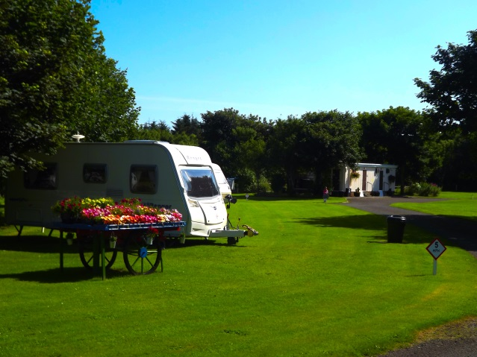
Opening Hours
15th April – 30th September 2017
10:00 -14:30 hrs.
17:00 - 21:00 hrs.

Daily Charges from
Tent Pitch and 1 Person £11.00
Tent Pitch and 2 People £16.00

Caravan Pitch and 2 People £19.00
Motor Home Pitch and 2 People £19.00

(Prices vary depending on time of year - please contact us if you wish an exact price)

For more information
Telephone 01955 605420
E-Mail: wickcaravansite@aol.com
www.wickcaravansite.co.uk


