Watea Boutique Bed and Breakfast

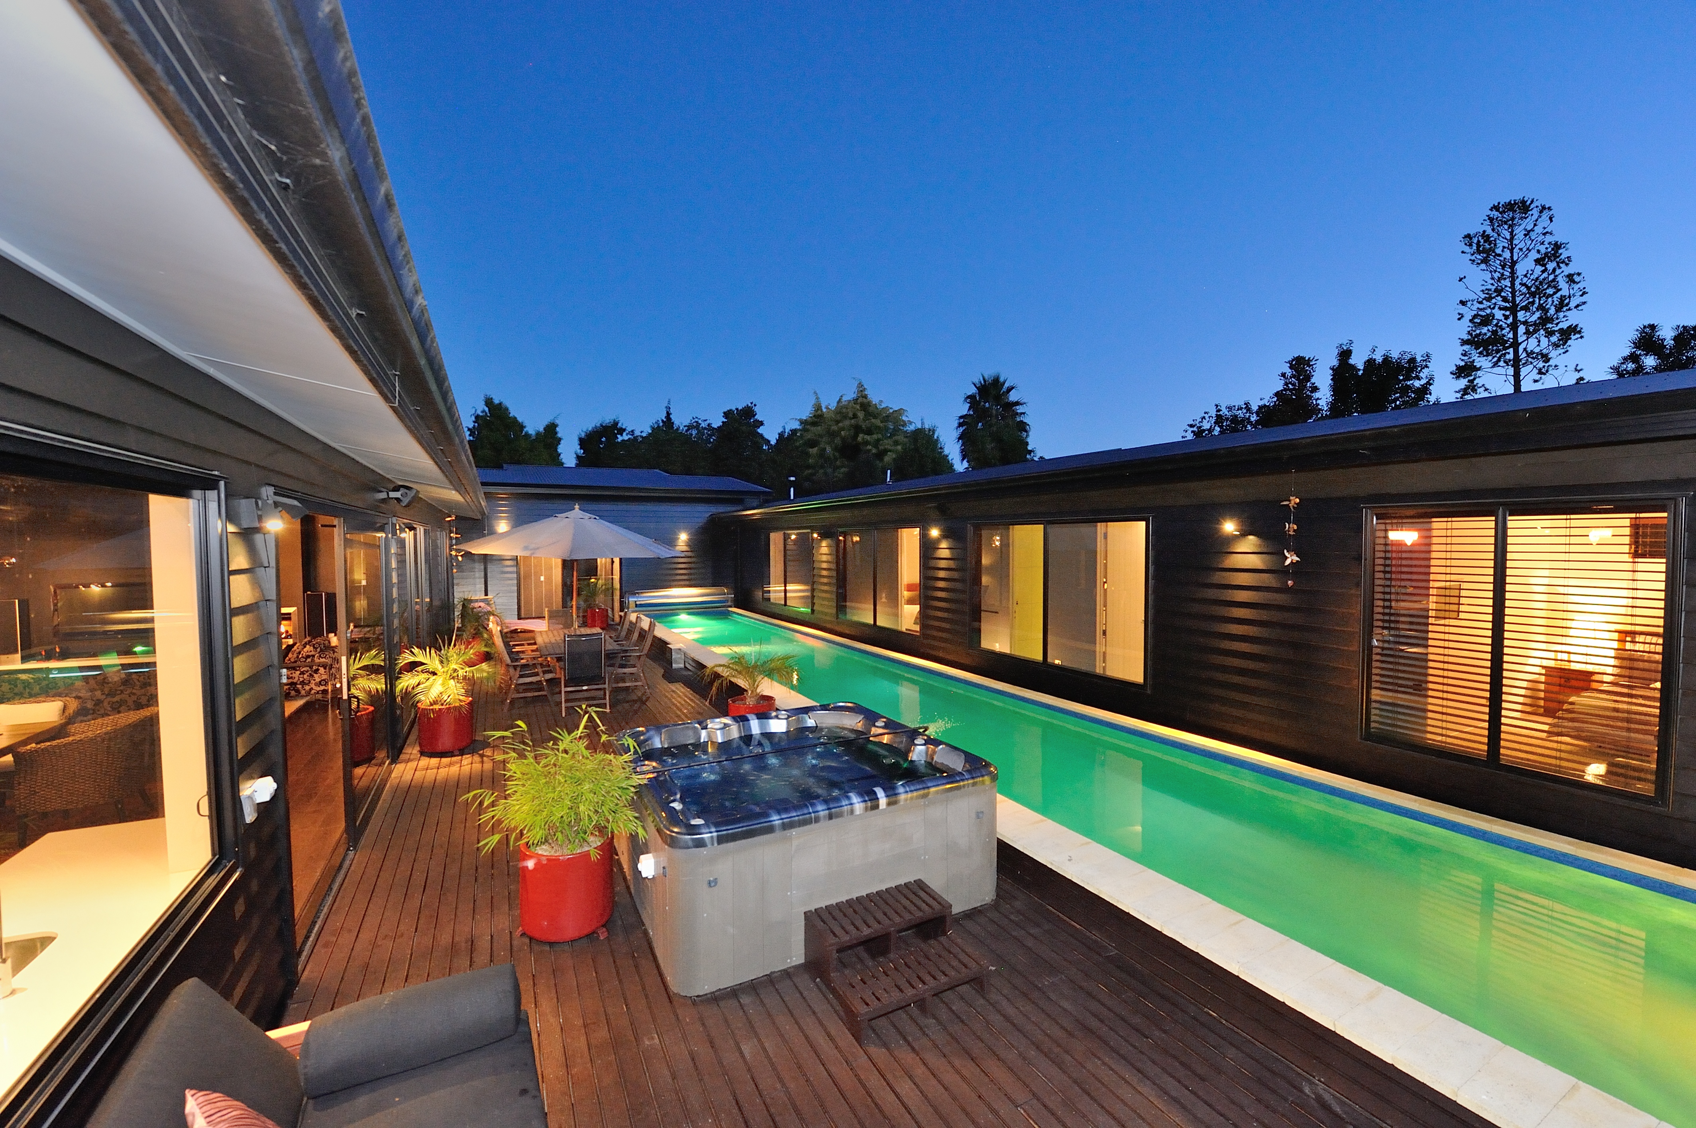

Our Service:
We have a very modern house and well appointed facilities. Our aim is to delight our guests with a personal service tailored to individuals needs. Our Trip Advisor reviews are a testimony to our guests very much enjoying their stay with us at Watea.

In May 2015 we were awarded by Trip Advisor, the 2015 Certificate of Excellence, for our consistently excellent Guests feedback. Watea opened in April 2014. Since then we have risen to being currently ranked no2 of 45 B&B’s and Lodges in Napier.

Arrival:
Guests are greeted on arrival and offered refreshments with home baking. Guest accommodation is in a separate wing of the house.

Bedrooms:
There are three bedrooms, Te Mata, Pania and Maui. All rooms have new comfortable super-king beds, luxury bedlinen, fridges, robes and tea and coffee making facilities. SKY TV is available in all rooms. With fibre to the house, there is unlimited high speed access to WiFi. Te Mata, the premier room, has an en-suite kitchenette, seating arrangement and direct access to the courtyard. The rooms are all large, Te Mata 25sqm, Maui and Pania 15sqm.

Bedroom Configurations:
The bed in Pania can be configured as two long singles if required.
Currently either Pania or Maui is offered to guests. Only friends / and / or family on request, are able share the very large 11sqm bathroom between these two rooms.
Maui has en-suite access to the bathroom between the Maui and Pania rooms. This means there are 2 rooms with en-suites.

Guest Lounge:
There is a cosy guest lounge with SKY TV and music to suit all tastes. There is a bed settee in this room, available on request for family get-togethers.

Central Courtyard:
Watea is built in Roman Villa style with a large private and sheltered central courtyard. Guests have access to the 18metre pool, spa pool, outdoor rattan furniture, outdoor TV and surround sound for enjoying the wonderful Hawkes Bay climate.

Breakfast:
Our intent is to make breakfast a pleasurable event for guests. Guests are offered a selection of continental with seasonal fruits, freshly squeezed juice, home-baked bread and seriously good coffee. A cooked course follows. Breakfast is served in the lounge area or in the courtyard depending on the season.

Aperitifs:
Drinks and aperitifs are offered on the evening of arrival and served either in the courtyard, or in the lounge area. We use this as an opportunity to understand guests’ interests and to provide help creating an itinerary to enjoy the many things the Hawkes Bay has to offer. We give guests as much or as little opportunity for interaction as they wish.

Wine, food and local knowledge:
Ewen is a serious wine buff. He works part-time as the cellar door at a local vineyard. We will suggest vineyards to visit and things to do depending on our guests’ level of interest in wine. We will host guests on a personal wine tour upon request.
Hawkes Bay has a huge variety of eating options, with many restaurants being world class. We provide guests with recommendations for dining out in the area based on our own experience. We make bookings and offer transport to restaurants.
We will prepare a dinner for guests on request and local produce is always on offer. We have an extensive wine cellar and we serve aged wines to complement the meal.

Guest Amenities
A small but well equipped gym, his and hers bikes and a set of golf clubs are provided for guests free of charge. The garden is an attraction for many guests with seating for quiet contemplation in the glade area.

Rates
Rates include GST and of course a full breakfast. Our wholesale rates are retail less 20% commission as follows;

Summer Season - 1st October till 31st May

Summer 2015 - 2016

Te Mata $228
Maui $220
Pania $204

Winter Season - 1st June to 30th September

Winter 2016

Te Mata $176
Maui $164
Pania $156

Summer 2016/17

Te Mata $252
Maui $236
Pania $220

Contact Information
Watea Boutique Bed and Breakfast
27 Jervois Road
Jervoistown, Napier, 4112
New Zealand

Website:www.hawkesbaybandb.co.nz
Trip Advisor; http://www.tripadvisor.co.nz/Hotel_Review-g255109-d6405946
Facebook;https://www.facebook.com/wateaboutiquebandb
Email1;info@hawkesbaybandb.co.nz
Tel: +64-(0)6-845-2167

Ewen Ritchie (co-owner)
Mobile: +64-(0)21-599-692
Email2; Ritchie.edj@gmail.com
Linked In; nz.linkedin.com/pub/ewen-ritchie/0/654/55b/
Twitter; @Ewenr

Iris Clanachan (co-owner)
Mobile: +64-(0)21-334-674
Email3; irisjclanachan@gmail.com



