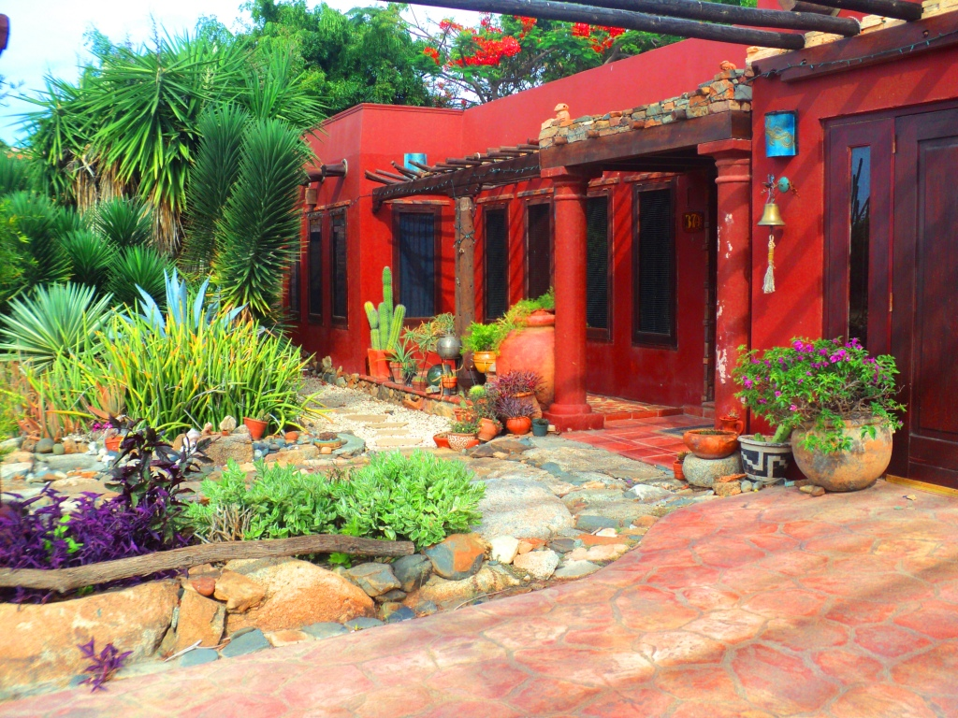
It is our pleasure to welcome you at our Native Aruban Art Gallery & Museum. Where all product and exhibitions proceeds from recollected material recycled in beautiful art pieces certified by Aruba`s Cultural department, which are inspired up on Aruba`s millenarian Cultures.
How to get involved:
Did you know that every morning we promote very special 1 hour personal tours at out location at Westpunt 37 A.
So make sure your reservation is booked in order to get acquainted whit this cultural aspect of our unique island that you will not find anywhere else.
Visit by appointment only, call at ++297-592-2702 or ++297-586-0242 or mail us at cayciba@setarnet.aw. Cost per person is $20.00 and a maximum of 4 persons per tour.
Like us on Face Book and share your personal experience with us on Trip Advisor.


