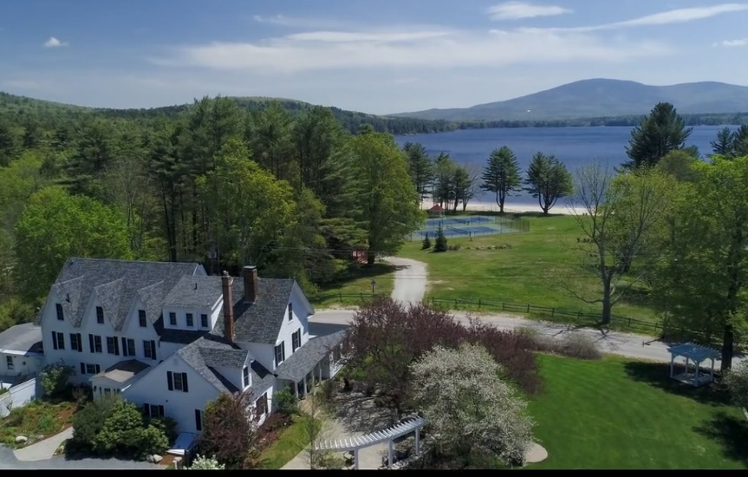
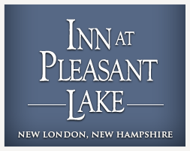

www.innatpleasantlake.com
853 Pleasant Street, New London, New Hampshire 03257
info@innatpleasantlake.com
Dine  Stay  Celebrate
800-626-4907
603-526-6271
Warm hospitality and beautiful views. Relaxation and adventure in all seasons. Inn at Pleasant Lake is a waterfront retreat in historic New London, NH. We are a full-service country inn that offers comfortable accommodations and gourmet dining in a tranquil New England setting. Whether you are looking for a quiet romantic escape, or an exhilarating outdoor adventure, we will provide an unmatched experience.

www.innatpleasantlake.com
853 Pleasant Street,
New London, New Hampshire 03257
info@innatpleasantlake.com
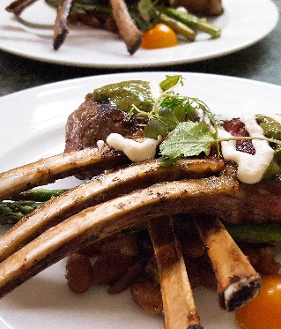
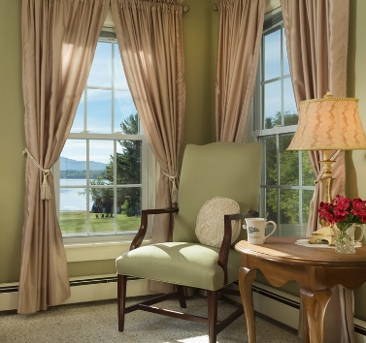
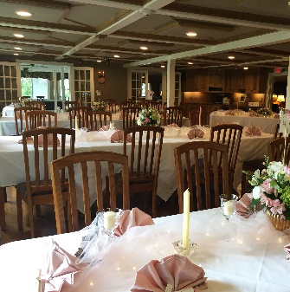
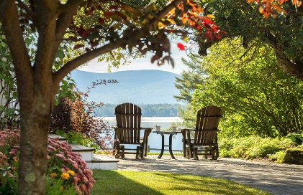
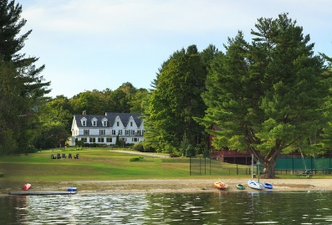
⬥ Dine 
• Breathtaking views of Pleasant Lake and Mt. Kearsarge
• Beach access with complimentary resort amenities
• Memorable and inspiring venue for guests and events
• Thriving community with activities to suit your interests
⬥ Stay 
⬥ Celebrate 
- Make Your Reservation Now –
ww.innatpleasantlake.com or 603-526-6271

• Open to the public Wed - Sun
• Top-rated restaurant in the area
• Locally sourced from farm partners
• Single seating, Prix-Fixe dinners
• Warm inviting atmosphere
• World-class, friendly service
• Authentic New England cuisine
• Warm, welcoming hospitality
• Relaxation in all seasons
• 10 junior suites and guest rooms
• Private baths, recently renovated
• Hearty breakfast; Afternoon tea
• Convenient packages & specials
• Luxurious amenities
• On-site bar and food services
• Custom designed weddings (2 - 200)
• Intimate elopement packages
• Private dinners, reunions, occasions
• Company parties and holidays
• Business meetings
• Privacy assured
• Technology enabled as needed

