Our Mission

“Kindness Inspires Kindness”

Maple Street Bed & Breakfast
Lamoni, IA 50140

B&B’s are quickly becoming the accommodation of choice for travelers.

Web site: www.maplestbnb.com
Phone: (641) 223-2575

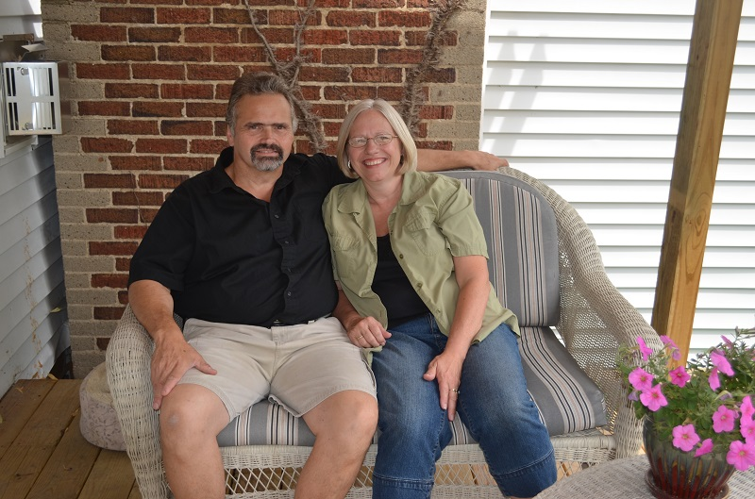
“Kindness Inspires Kindness”

Innkeepers Cliff and Janie Neeley
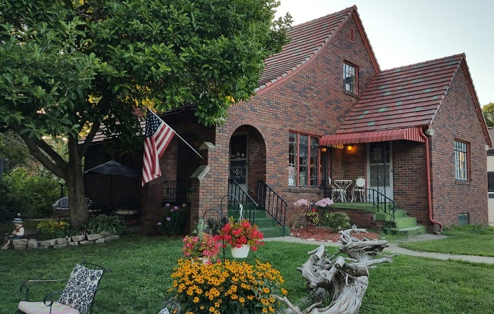 Corner of N Maple and Main St. in Lamoni

M

Just two miles off I-35 between Kansas City, MO & Des Moines, IA, places you in the heart of historic Lamoni, and within walking distance of Graceland University, restaurants, Coliseum movie theater, bike trails, antique stores, gift shops, and the community park with playground and outdoor swimming pool. Treat yourself to luxury in our guestrooms featuring LCD TVs, fireplaces, fine linens, and plush pillowtop bed then wake to a gourmet breakfast, or just sleep in! Just steps away, our second B&B (and home) offers overflow accommodations for events such as weddings, funerals, family celebrations, and crafting retreats. Gather on the front covered porch, on the back deck (with hot tub and grill) or in our two spacious great rooms with fireplaces!
“Check this place out! We've stayed here several times and we have never been disappointed. I won’t stay anywhere else.”
We welcome you to our Bed and Breakfast, an early 1900’s English Tudor, downtown on Main Street in the lovely town of Lamoni, Iowa. Maple Street Bed & Breakfast offers a unique overnight experience providing guests with a relaxing evening and restful night. The simple country atmosphere encourages leisure, quiet life reflection, and the release of stressful thought. Feel tensions melt as you sit on the front patio furniture or relax on our front your swing watching Amish buggies drive by. Stroll to unique shops, art galleries, coffee shops, restaurants, or the movies. A ten-minute walk takes you to Graceland University. When the customer leaves us behind, they will be rested and well nourished with an old-fashioned home-cooked breakfast. Our guests will know the true meaning of kindness expressed in our offering of hospitality were “Kindness Inspires Kindness.”
Innkeeper/Owners
Cliff and Janie Neeley

Neeley’s
Maple Street
Bed and Breakfast
108 N. Maple St.
Lamoni, IA 50140
(641) 223-2575

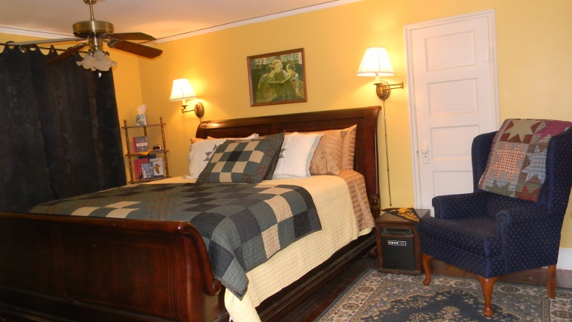
Graceland Room
This luxurious room with a King Size Sleigh bed and plush pillow top mattress with is a favorite and is on the upper floor. This room shares a bathroom with the Hope room but can be rented with a guarantee we will not rent the Hope room. Hope room can be added to this room, for half price. (Graceland Suite at $130.00) Rents for $87.00 plus tax.
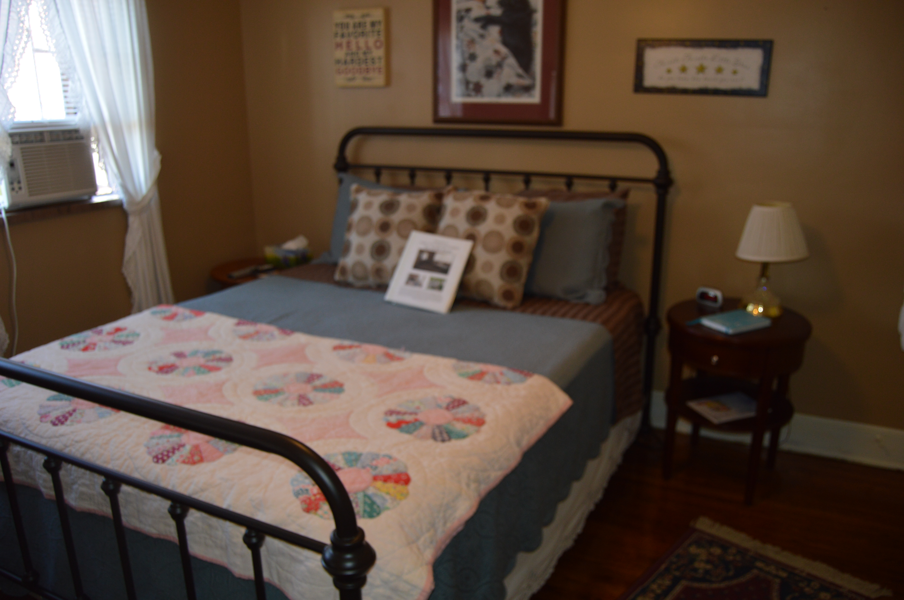
Hope Room
This charming room with a queen bed, pillow top plush mattress, is on the upper level and can be added to the Graceland Room for half price. (Graceland Suite at $ 130.00. Rents for $87.00 plus tax.

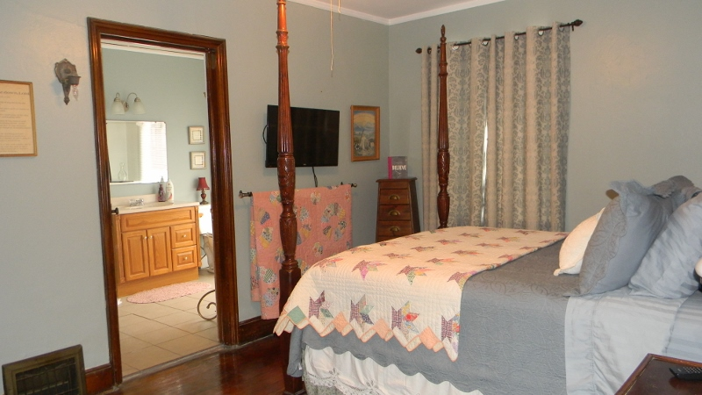
Shalom room
This peaceful room has a Queen four-poster bed with extra-plush pillow top mattress and spacious private bath with shower. The Shalom Room, located on the main floor. This room rents for $87.00 plus tax.

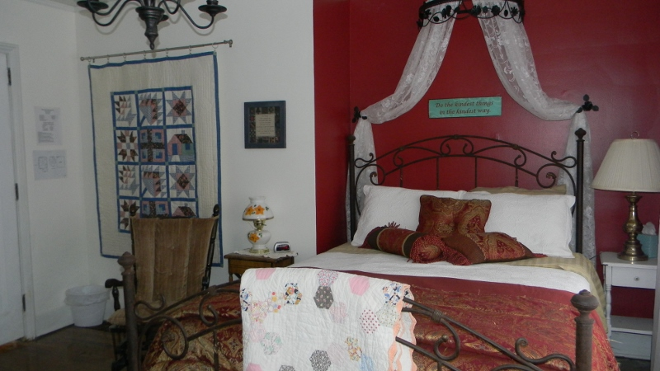
Journey Room
This "red and white room" is a guest favorite! It has a Queen bed (plush pillow top mattress), and private bath with extra large walk-in shower. The Journey Room is on the main floor. This room rents for $87.00 plus tax,
Amenities
- Central air plus an air conditioner and a ceiling fans or floor fans all rooms
- Large front yard facing Main street with tree hung swing,
- Gardens, front and back yard patio with comfortable lawn furniture.
- “Gathering” room with fireplace
- Plush hotel robes and towels
- Guest microwave and refrigerator for guest use
- Secure Wi-Fi
- First night evening snacks
- Television in each room
- Pillow-top mattresses
- Free local and long distance phone calls
- Airport shuttle arrangements can be made.

Local Interests (walking Distance)
- Amish Community and stores
- Antique Shops and art galleries
- Graceland University
Shaw Center for the Performing Arts
Helene Center for the Visual Arts
Pro-Am Disk Golf Course
- Coffee house California Style
- 6-mile paved bike-walking trail
- Coliseum Movie Theater across street
- Southern Iowa Gateway Welcome center
- Lamoni Golf and Country Club
- Liberty Hall Museum
- 3 City Parks-swimming pool
- “Quilt City of Iowa”

*2014: Lamoni was named one of America’s best 100 communities for children for the 13rd year.

Please call for more information regarding children and pet policy.

