La Vida Loca Winery

La Vida Loca Winery is a family owned business dedicated to producing the highest quality of grape, fruit and cooking wines possible. We offer the largest varieties of wine in the area, so remember to keep an open mind when visiting and try a few flavors out of your normal comfort zone.

Our Mission

To make excellent wines gently sweetened to enhance the flavors. We strive to make your experience with us pleasant and very memorable.

Winery History

The Putz family moved to a home in rural Warren County in 1987, where many varieties of berries were found growing on the property. Tony began making wine as a casual hobby. When neighbor and relative, Ron, tasted the wine, he started picking fruit and taking a real interest in producing wine. As other people discovered the different varieties of wines, it became evident that this would become a venture worth
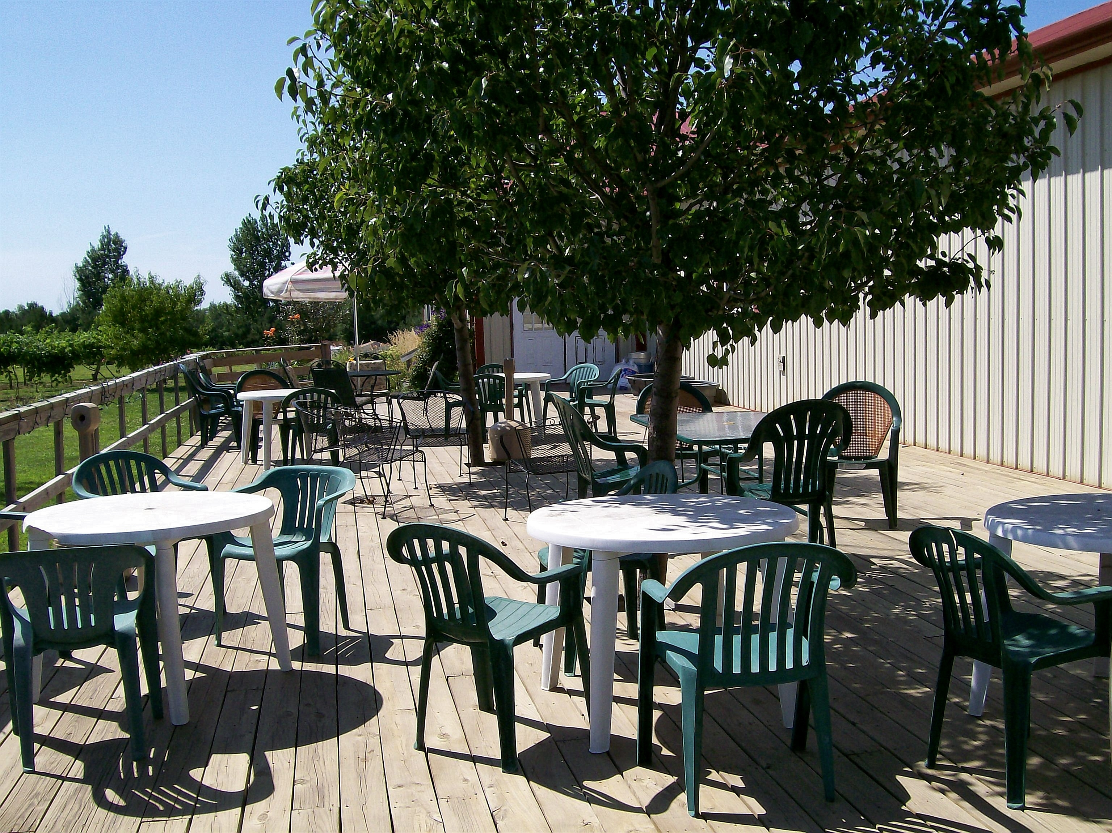

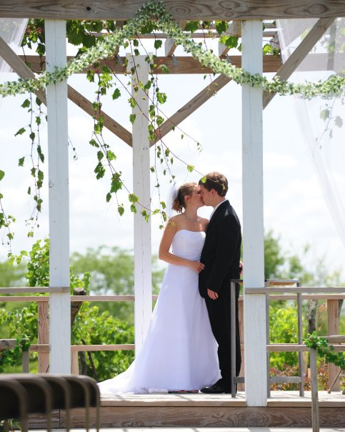

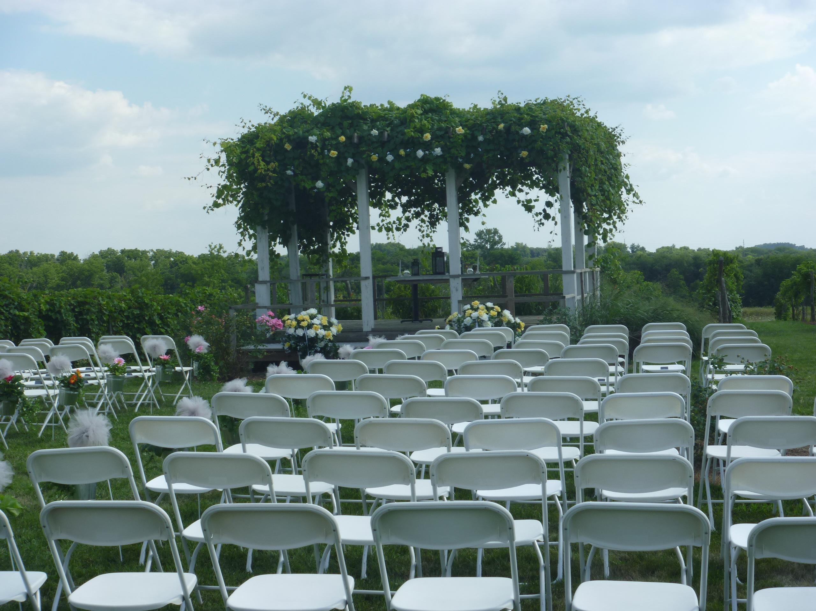
undertaking. The winery was built in 2002, with the reception room added in 2004. When you enter the winery you will experience a light and pleasant atmosphere, and you’ll feel like family. Tony and Ron are often sharing stories and laughter with friends (our customers).

Wine Sampling

Wine sampling is available in our tasting room during regular business hours. Please contact the winery if you should have a group of 8 or more people. We have wine, beer and soda available for purchase at the tasting room.

Reception Room

Our reception room is perfect for all types of formal or informal events

. Seating capacity is 150 persons. In addition to the reception room there is a pergola in the vineyard perfect for any wedding ceremony, catering kitchen, serving area, dance floor, coat/guest area and a 1600 sq. ft. deck.

